**Reattempt MSA 4**

**Question:**

Create a web based application for Voter registration Fields :

* Id : textbox
* Name : Text Box
* Gender : Radio button
* State : Dropdown box(All the states should be there)
* City : Dropdown box. But based on first dropdown box that is state , the city will come accordingly.

----------------------------------------------------------------------------------------------------------------

**BACKEND:**

**MYSQL:**

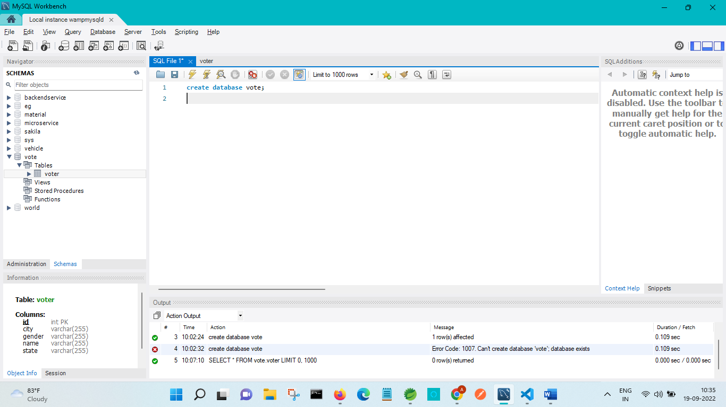

**SPRINGBOOT MICROSERVICE:**

SERVICE-REGISTER

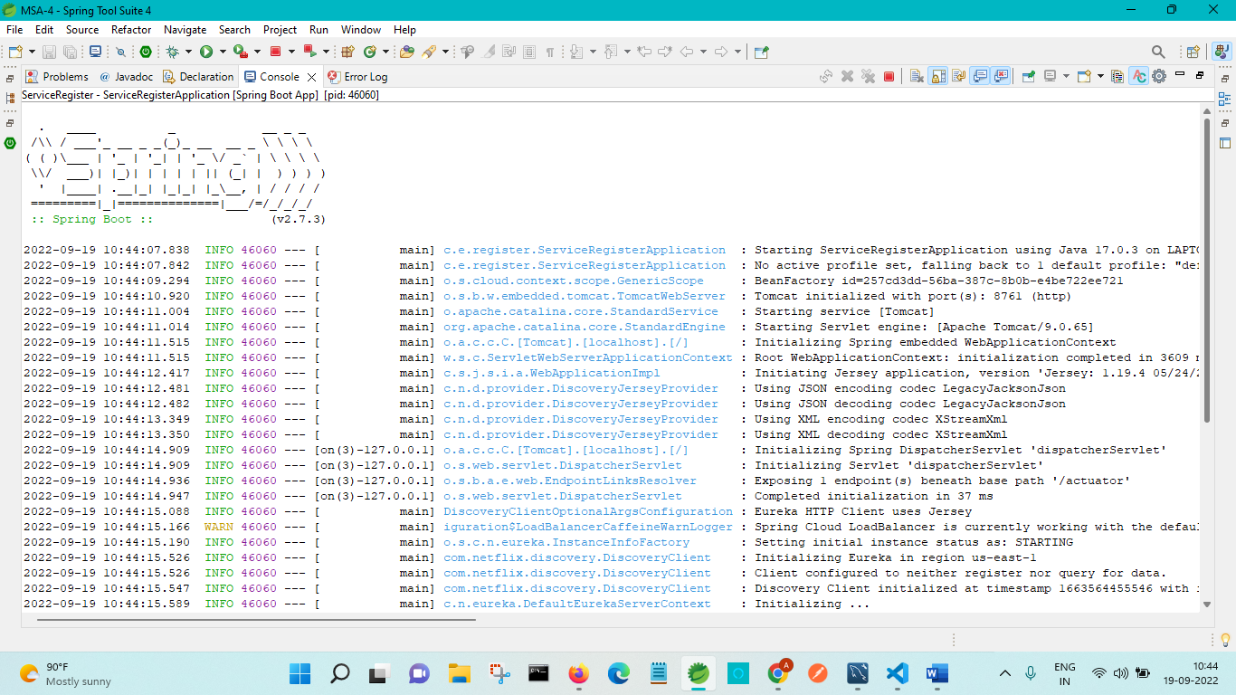

API-GATEWAY:

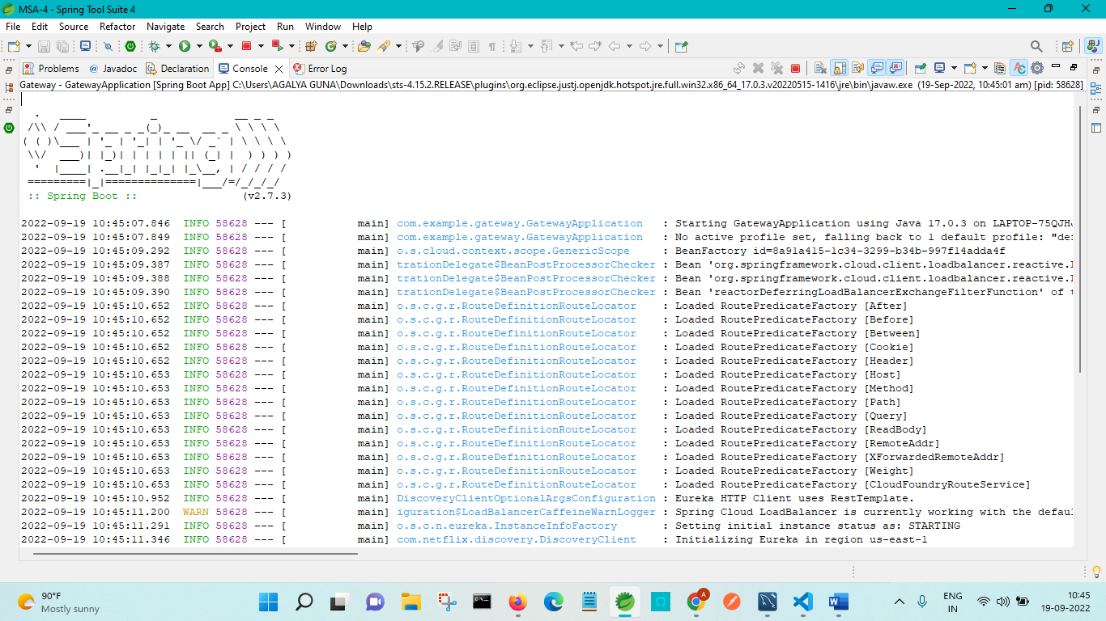

VOTER-APPLICATIION:

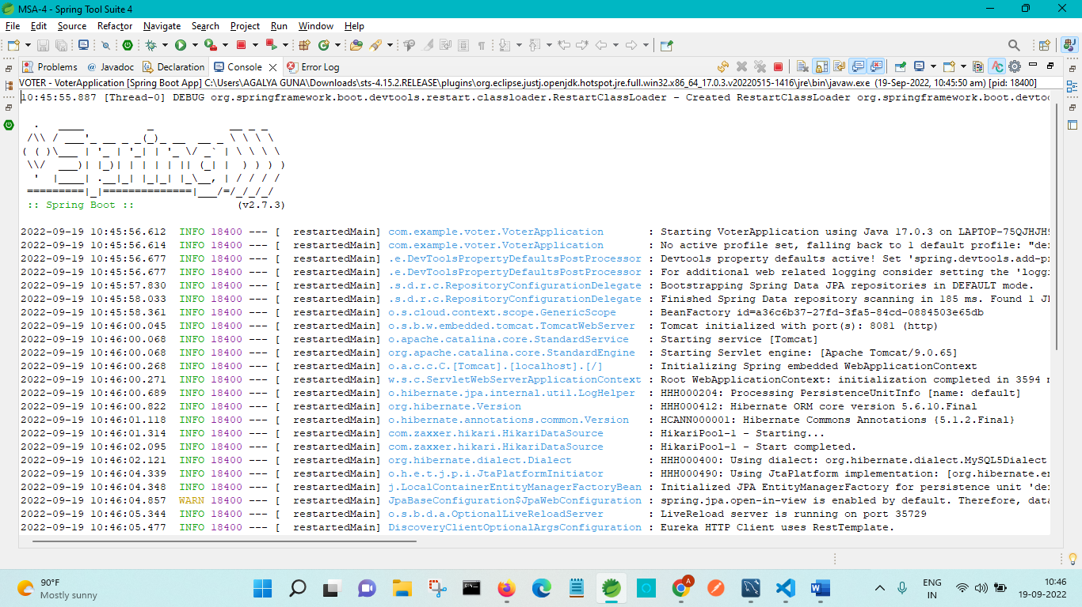

**FRONTEND:**

TERMINAL WINDOW:

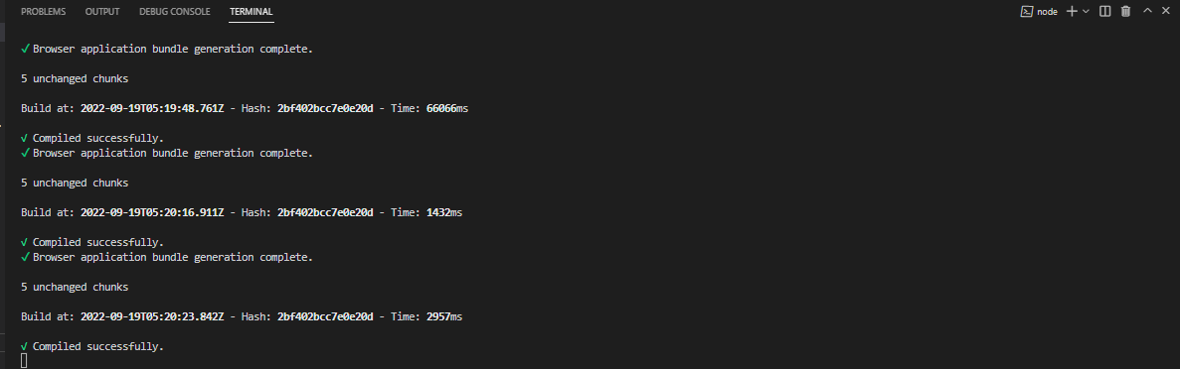

HOME PAGE:

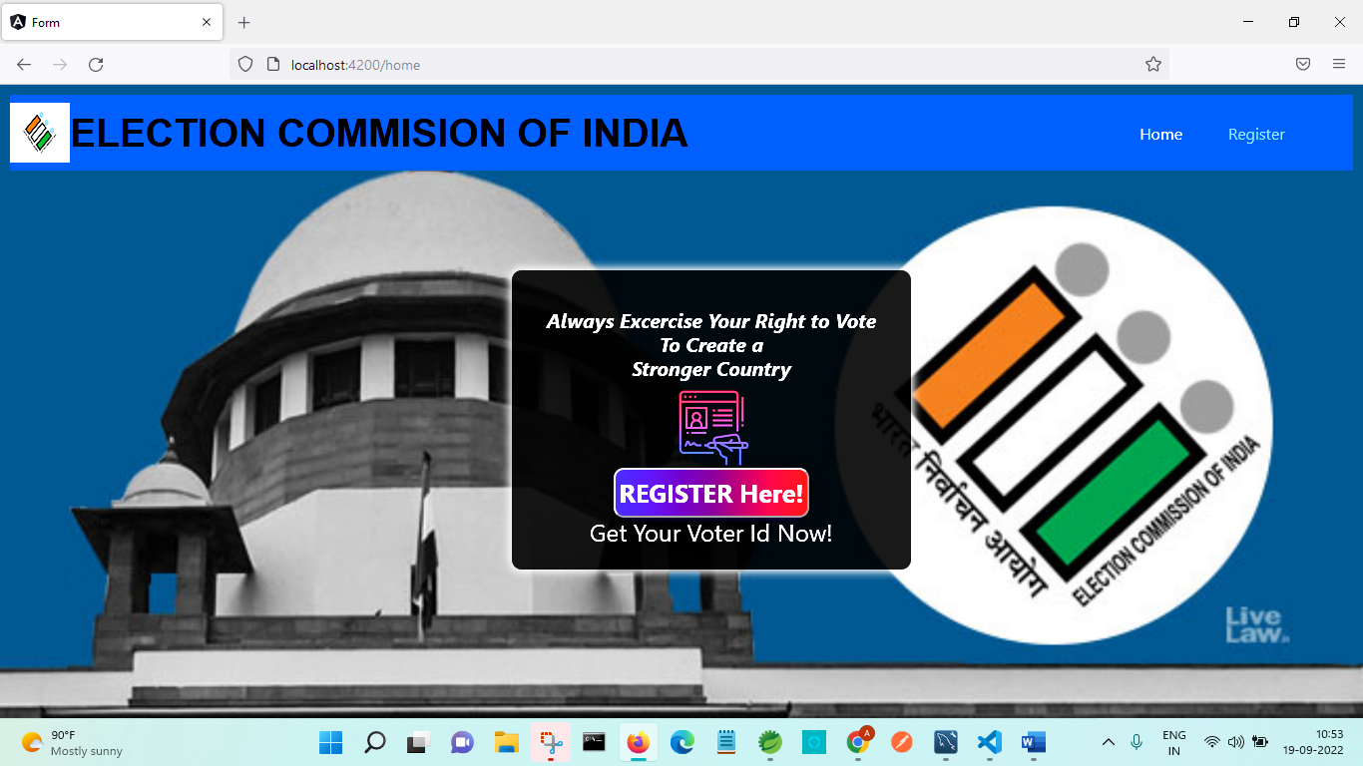

REGISTRATION PAGE:

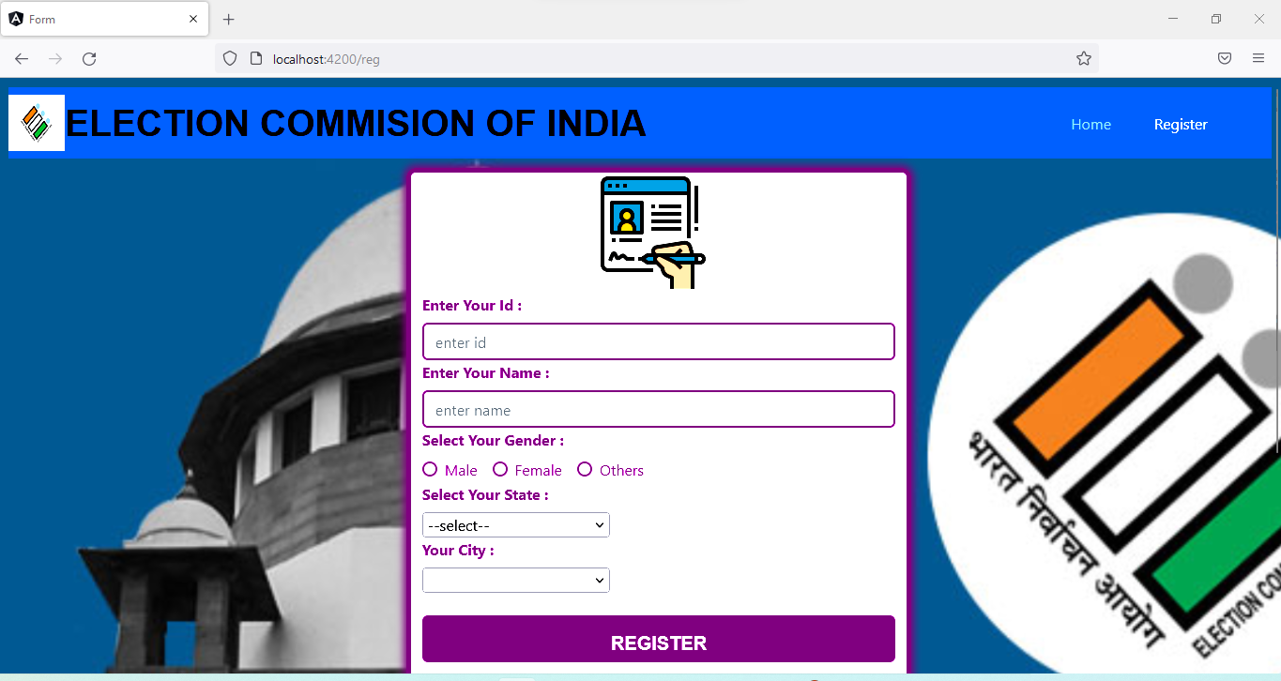

CITY-DROPDOWN AND STATE-DROPDOWN:

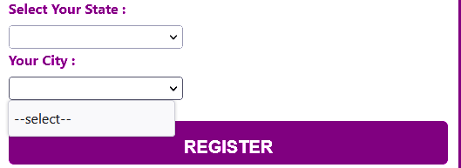

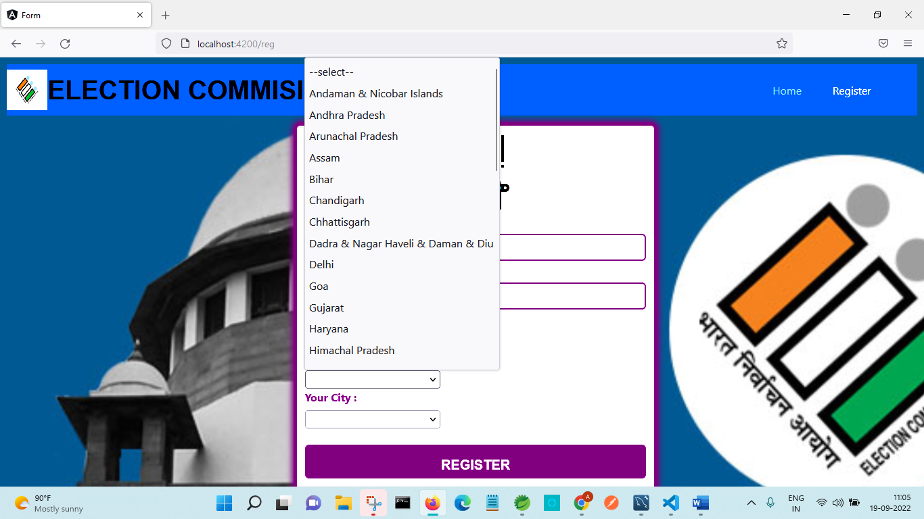

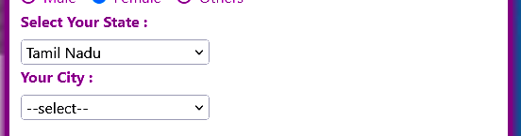

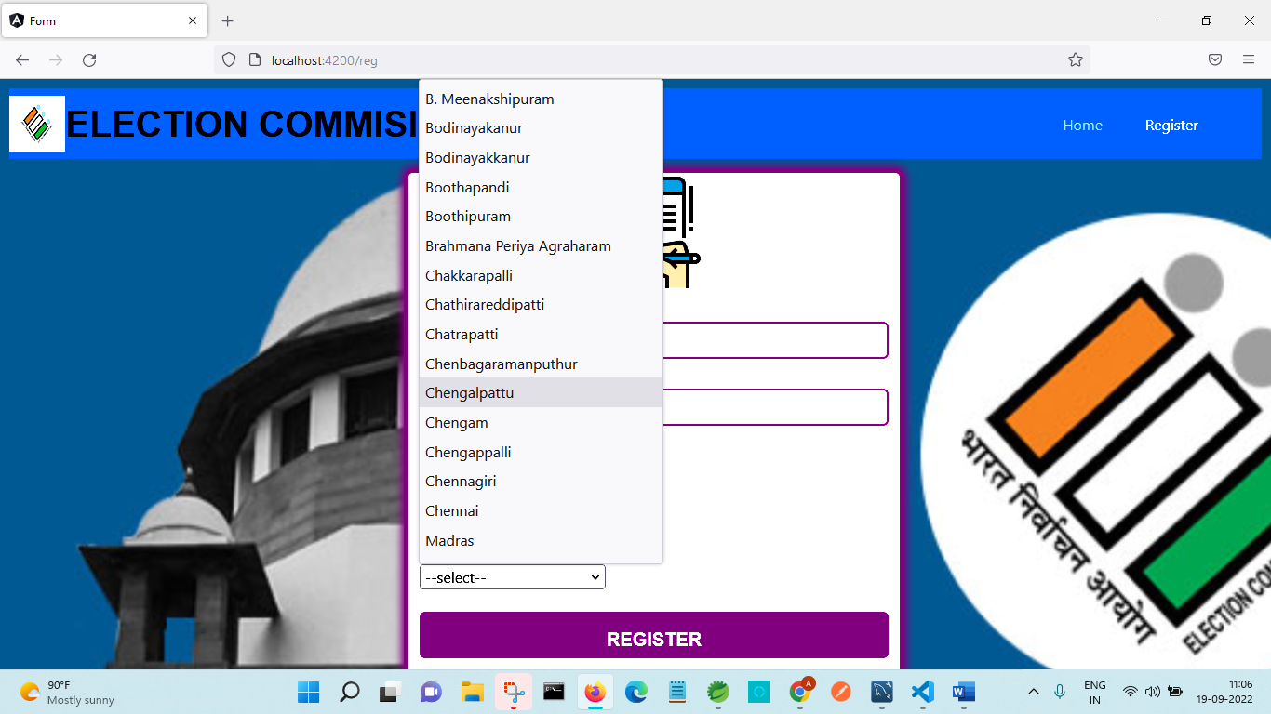

SUCCESSFUL REGISTRATION:

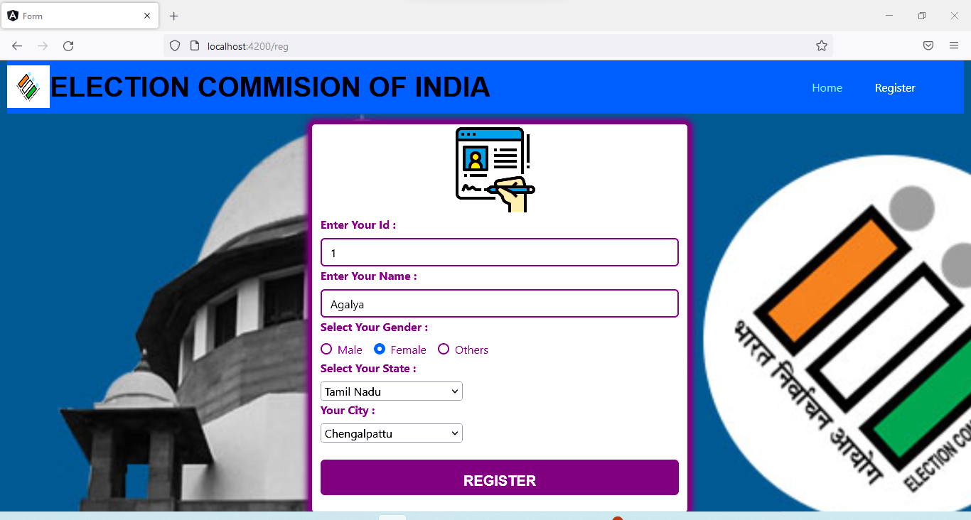

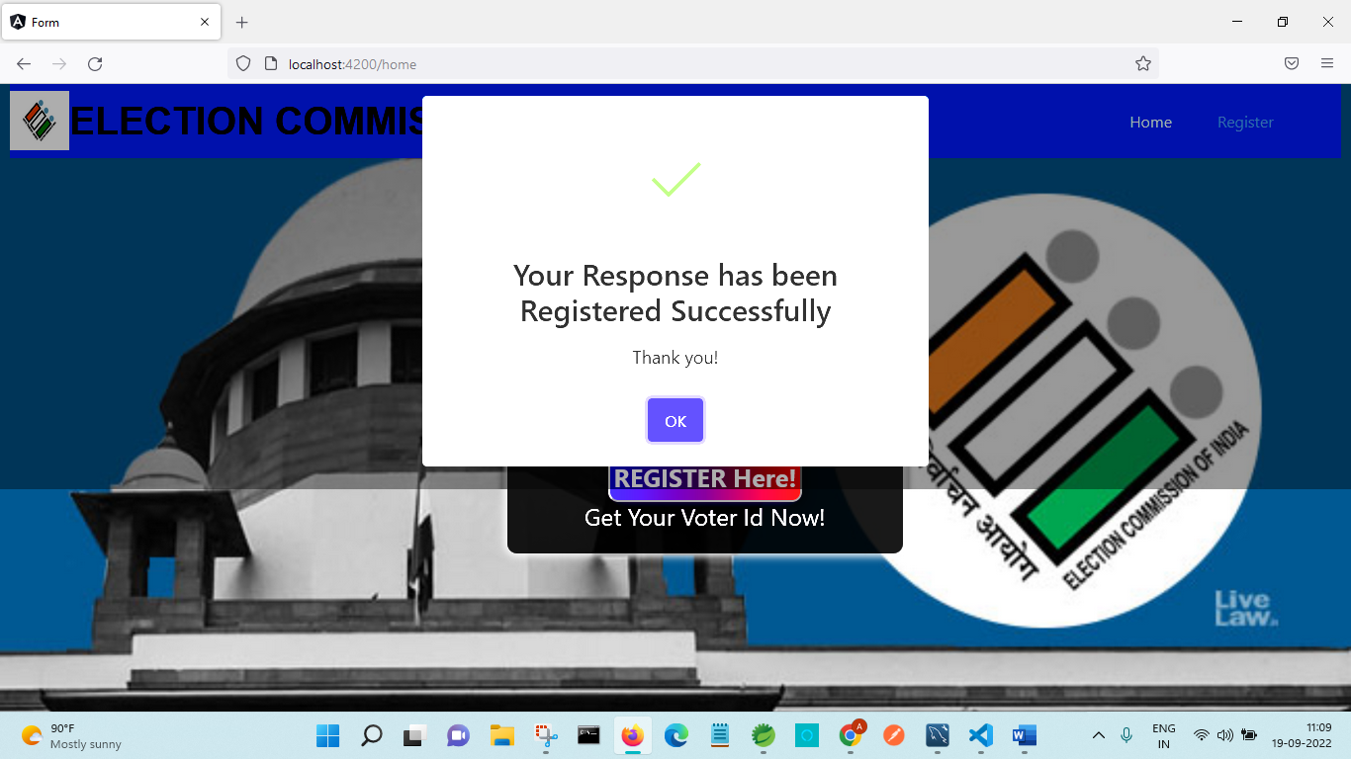

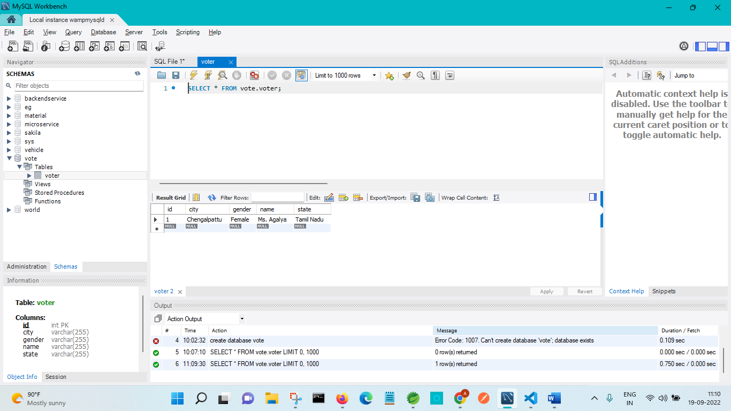

HANDLING EXCEPTION IN FRONTEND FROM BACKEND:

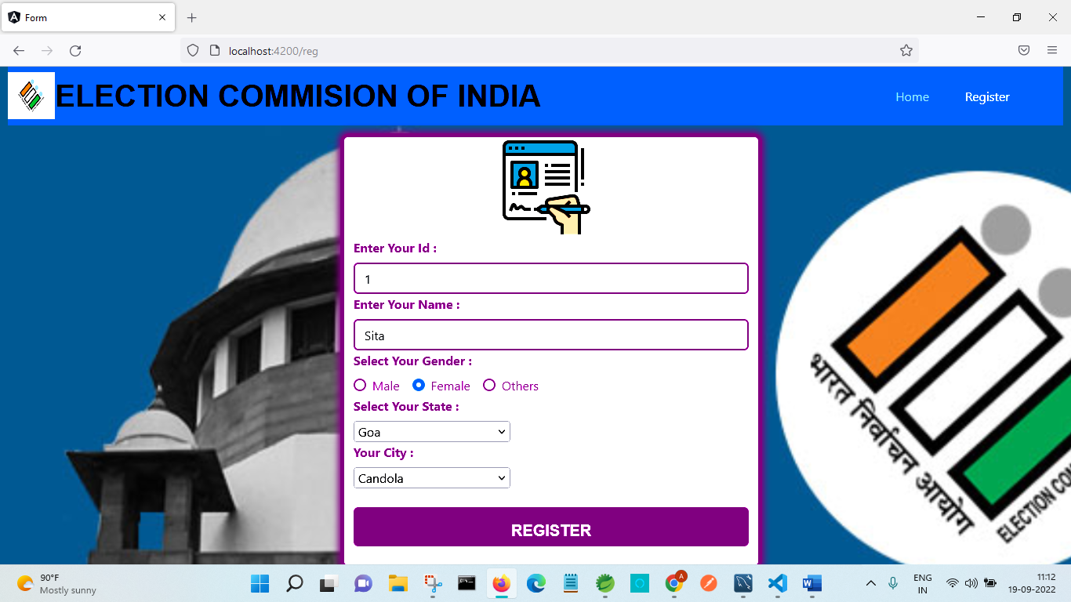

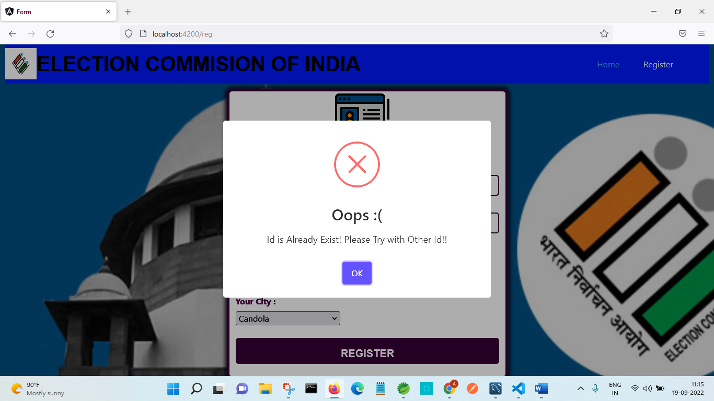

FORM VALIDATION:

